Lecture 13: Putting together the pieces

Putting together the pieces
- MIFIRA analytics by specific subquestion
- Triangulating findings
- Monitoring
- Triggers

Readings
- Michelson, H., E.C. Lentz, R. Mulwa, M. Morey, L. Cramer, M. McGlinchy and C. B. Barrett, “Cash, Food or Vouchers in Urban and Rural Kenya? An Application of the Market Information and Food Insecurity Response Analysis Framework,” Food Security, forthcoming.
http://dyson.cornell.edu/faculty_sites/cbb2/MIFIRA/apps/
- Mude, A. G., R. Ouma, and E.C. Lentz, “Responding to Food Insecurity: Employing the Marking Information and Food Insecurity Response Analysis framework in rural Northern Kenya.” Journal of Development Studies, forthcoming. http://dyson.cornell.edu/faculty_sites/cbb2/MIFIRA/apps/
- Hill, E., J. Upton, A. Xavier, 2011. “Local and Regional Procurement in Uganda: Lessons learned from a pilot study of the Market Information and Food Insecurity Response Analysis (MIFIRA) framework. July. Draft. http://dyson.cornell.edu/faculty_sites/cbb2/MIFIRA/apps/

Introduction to putting together the pieces
In this lecture, we review the suite of analytics presented in earlier lectures and link them to the MIFIRA questions. Recall that MIFIRA is supported with needs assessments, analysis of the local context, and review of informal and formal policies. Needs assessments can provide information about individuals’ food security context and livelihoods as well as about local communities and marketsheds. Analytics that examine the local context include a review of marketshed characteristics, seasonal calendars and market maps. Policies can limit or increase incentives for trade, both by traders and by households. Understanding how recipients, traders, consumers, and producers respond to policies can explain market behavior and identify possible anomalies. Lastly, we focus on aspects most likely to be important for food insecure households.

A key theme in this wrap-up is the need to exercise careful judgment – about data quality, about the most important considerations in the specific response context, about the strength of findings with respect to individual sub-questions, etc. – and to monitor for changes in circumstances. Combining the various analytics that go into the MIFIRA framework so as to generate prescriptive assessments involves as much art as science. No mechanical formula exists to integrate the various answers. The analytics developed in the preceding lectures and structured following the MIFIRA framework provide an solid evidence base from which sound assessments can be reached as to the best-bet response(s) to a given food insecurity situation. But it is not a cookbook approach. Rather, MIFIRA is a structured system of inquiry that complements, and must be complemented by, other, ongoing information collection and analyses (e.g., needs assessments, monitoring and evaluation). In what follows, we offer some final key bits of guidance in pulling the various pieces of the MIFIRA inquiry together into a coherent whole.

MIFIRA analytics by specific subquestion
The analytics used to support a MIFIRA analysis can roughly be divided into analytics related to recipients and consumers (demand side) and analytics related to suppliers and source markets (supply side). Recipient and consumer analysis tools assist in understanding access, preferences, and demand. Suppliers and source market analysis tools can assist in identifying source markets, supply responsiveness and competition. By combining demand analytics with supply responsiveness and competition, we can estimate equilibrium effects – e.g., what is likely to happen to prices if we distribute cash or if we source food locally? – as was demonstrated in the last lecture on local supply responsiveness. Answering those sorts of equilibrium response questions is central to answering the two fundamental questions that motivate response analysis: are local markets functioning well? And is there sufficient food available nearby to fill the gap? Here we briefly map out how to integrate the different elements and tools discussed in the previous lectures so as to systematically address the MIFIRA sub-questions. We strongly urge users to work through the examples provided in the Michelson et al. (forthcoming) and Mude et al. (forthcoming) MIFIRA studies on Kenya to see good examples of applications in very different settings.

Demand Side
1a. Are food insecure households well connected to local markets?
- Basic info: which markets, for what products, when?
- What constrains access?
  - Inter-community constraints
    - Distance, safety, costs, seasonal accessibility and/or surpluses
  - Intra-community constraints
    - Socio-cultural reasons (gender, caste, marital status, etc.), safety, OVCs, health/disability constraints (HIV+ households)
  - When are access constraints insurmountable?

1b. How will local demand respond to transfers?
- By how much will demand shift?
  - The form of the transfer matters
  - The amount of the transfer matters
  - The targeting of the transfer plays a major role
- The demand effects of transfers are typically greatest among poorer households and in lean seasons.
- Methods for understanding demand
  - Elasticities
  - General formula for elasticities:
e_{ij} = (Percentage change in variable i) / (Percentage change in variable j)
  - Marginal propensities to consume
    - If income increases, what is the amount that demand increase?
    - MPC = Change in consumption / Change in income
    - Consider estimating an MPC in the field
      - Where income elasticities are unavailable or unreliable
      - Verify estimates
  - Terms of trade
  - Upper and lower bounds

1e. Do food insecure households have a preference over the form/mix of aid they receive?
- Elicit preferences
  - Identifies not only preferred transfer but also issues and concerns of households or individuals
  - When eliciting preferences, the analyst ought to provide information on how transfers would most likely be delivered as preferences may be conditional on distribution mode (e.g., private or public)

Methods of understanding access and preferences:
- Information sources:
  - Expenditure data
  - Rapid Appraisals
  - Key Informant interviews
  - Household surveys
  - Focus group discussions
    - by gender
    - by target population
  - Inter-community differences
    - Marketshed mapping

Supply Side
1c. How much additional food can traders supply at or near current costs? & 2b. Will agency purchases drive up food prices excessively in source markets?
- Trader capacity to respond to demand increases
  - Price analysis: market integration and IPPs
  - Availability and trade
  - Barriers to trade expansion (including policies)
  - Supply chains and market maps
  - Eliciting marginal costs to compute local supply responsiveness

1d. Do local food traders behave competitively?
  - Marketing margins
  - Counts, CR4, HHI
  - Structure, conduct, performance

2a. Where are viable prospective source markets? & 2c. Will local or regional purchases affect producer prices differently than transoceanic shipments?
  - Market integration and IPPs
  - Formal and informal policies
  - Availability
  - Program comparisons

Triangulating findings
Ideally, each MIFIRA subquestion will point toward the same finding: that markets are (or are not) functioning well, or that supplies are (or are not) locally available for purchase. See Michelson et al. (forthcoming), Mude et al. (forthcoming) and Hill et al. (2011) to work through step-by-step examples of MIFIRA analyses and the conclusions about transfer choices the authors draw using the frameworks. When the findings are internally consistent, the prescriptive findings are straightforward. Cash should be targeted to those with relatively good market access under more competitive conditions, and food to those with relatively poor market access under less competitive conditions. The value of transfers should be adjusted (i.e., indexed to inflation) to remain equivalent to a cost of a basket of basic goods (or the cost of a nutritionally complete food basket). A mixture of cash and food is commonly desirable unless markets are truly failing, as in the case of hyperinflation, when logistical or financial bottlenecks limit additional throughput capacity to relatively remote and inaccessible locations, or when one or a small number of traders has considerable market power over pricing.

Sometimes sub-question-specific findings within a MIFIRA analysis will conflict, however. First, there is no concrete rule for when a market should be considered to be “functioning well.” In general, markets supporting large volumes of trade and that are well-integrated with other, larger markets in the area are considered well-functioning. Unfortunately, firmly establishing that a market is functioning well is often difficult due to lack of data. Therefore, an analyst will have to use judgment. As a general rule of thumb, if there are major concerns that cannot be addressed through other analyses, be cautious about relying on markets. Careful and regular monitoring combined with flexibility across transfer forms will enable programmers to rely on market-based interventions more.

Second, different analytics may produce conflicting findings, even to the same sub-question. Conflicting findings may be the result of several different reasons. Data quality, underlying assumptions, and geographical reach and applicability are three major reasons.

So how does one sort among potentially inconsistent findings? First, all else equal, trust analyses based on higher quality data over those based on less certain or specific data. When utilizing secondary data, this may require investigating further into reporting and measurement approaches and the possibility of data manipulation for political or other purposes. Secondary data series may give conflicting results due to how prices are measured, what markets are monitored, whether scales are used during price collection, etc. It may be that primary data collected locally is more trustworthy and more representative of the local population’s situation than secondary data available at more aggregated levels. This means that an analyst will need to understand the local context and to make a judgment call regarding the relative soundness of secondary data.

Second, underlying assumptions and choice of confidence bands may shape results. State clearly the underlying assumptions of each analysis and check for consistency across analyses. Given the inevitable imprecision of most quick-and-dirty analyses, the point estimates of analyses may actually fall within reasonable confidence intervals of one another, i.e., they may be reconcilable once one acknowledges likely measurement, sampling and specification error in the analysis.

Finally, macro level findings may not be reflective of micro level situations in food insecure areas. Therefore, paying attention to the geographical reach of results (e.g., secondary data are collected from major markets and often ignore smaller markets being targeted for an intervention) can help an analyst determine which analytics of the MIFIRA framework to weight more heavily.

Building flexibility into programming, including periodic re-evaluations of the situation through ongoing monitoring of updated secondary data and selective revisiting of key informants and focus groups, will enable switching between transfer forms if and when a particular form is no longer appropriate. Although this is administratively complex and there are few good rules of thumb available regarding appropriate mixtures of cash and food, the inherent flexibility of mixtures means that agencies can adjust the mixture as market conditions improve or deteriorate. In the face of poorly functioning markets and limited supply, flexibility can improve livelihoods by offering households greater choice and some food security while also enhancing market functioning.

Monitoring
Monitoring should always be ongoing in an information gathering, planning and analysis process. In the below figure, monitoring is depicted as the outer ring, feeding information into the planning and analysis and program implementation cycles that are the inner rings.

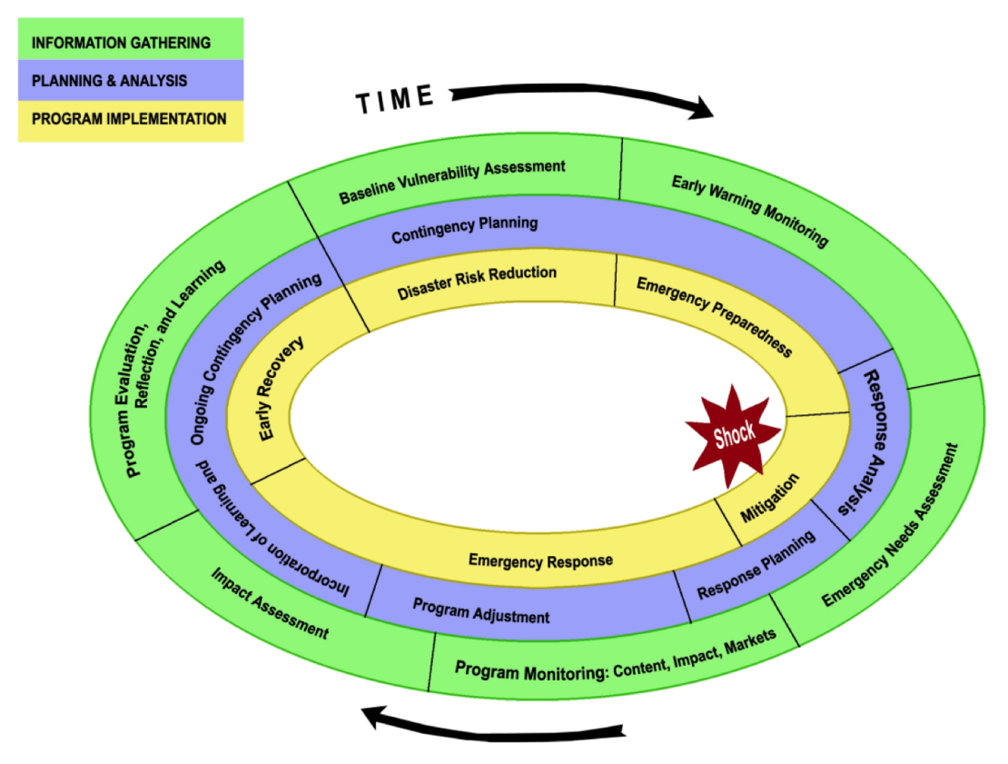
Source: Barrett et al. (2009)

Monitoring is essentially concerned with three separate arenas. One is simply monitoring the context (this usually falls under the heading of Early Warning, although it includes both “pre-crisis” information and ongoing monitoring during and after a crisis). The second, closely related to the use of this tool, is on-going monitoring of market conditions. Market conditions prevailing at the beginning of a crisis, or at its peak, may suggest one kind of response, but markets may recover from the impact of a shock and be much better (or less) able to function later on, which may completely change the analysis of what constitutes the best-bet response in this context. Thus a critical part of on-going monitoring is to keep track of changes in the market. The third monitoring task is about the impact of whatever intervention has been introduced. The remaining discussion deals mainly with the second and third issues – monitoring changes in markets.

Throughout a market assessment, a common-sense understanding of the context of the crisis, how markets operate in local communities, what government policies regarding markets and traders are, and traders’ expectations and abilities to meet demand can help agencies further decide what particular aspects of the market need more careful assessments. Leading and current indicators, such as those related to food availability and access, will be more helpful in monitoring changes in the market than will other, intrinsically lagging indicators focused on utilization.

As a general rule, the less precise a market assessment is, the more important careful monitoring becomes. Tailor monitoring to reflect uncertainty about particular aspects of the response analysis. For example, if non-competitive behavior is a concern, monitoring market entry and exit, trader capacity to expand, and marketing margins as these are key areas of uncertainty. Similarly, if an area experienced a crisis, examining market integration and supply chains regularly may help to clarify whether a market is recovering and traders are able to establish trade linkages and exploit arbitrage opportunities.

Monitoring prices
We focus on monitoring prices leading up to and during an agency’s intervention. Assess the duration and the direction of the change in prices, controlling for underlying inflationary and seasonal patterns in the broader economy. Graphing local and major domestic market commodity prices can be particularly helpful in identifying and tracking slow-onset crises or regional markets were food is becoming relatively more costly.

Three methods of ongoing price monitoring include comparing data to expectations, comparing data to estimated confidence bands, and comparing price increases to a fixed percentage increase (e.g., a common rule of thumb is 10 percent month-on-month). These methods can identify whether the situation has evolved enough to trigger further market analysis. On-going monitoring can identify creeping inflation or other slower moving changes. Similarly, price spikes or unusual volatility can be identified when current prices are benchmarked against historical data trends. If prices are volatile, increasing rapidly, or have increased more than some threshold (e.g., 10 percent in one month), consider expected duration and evaluate markets in order to determine if a non-cash transfer may be more appropriate. Finally, if re-evaluating the response analysis is warranted, focus on aspects that have changed. Don’t redo every element of the analysis.

While monitoring prices can tell us when something is wrong, monitoring prices, in and of itself, can rarely tell us why these prices are changing or identify what the underlying factors are that may be causing these price changes. When a price change occurs, we need to rule out and/or rule in possible factors that could contribute to a price change. Trader expectations, historic trends, and projections (e.g., of production) may provide information on whether the current situation is expected to improve or deteriorate, and for how long. These data may be helpful when assessing whether observed changes are one-off anomalies or indicative of longer-term or systemic changes. A change in prices is not necessarily the result of an agency intervention. Therefore, price monitoring often includes identifying and assessing underlying factors that could cause price changes.

Monitoring recipient impacts
Periodic discussions with households regarding local markets’ responsiveness and monitoring the changes in the market can help to determine if households’ current needs are being met with the previous programming decision. Revisit questions 1a and 1e: “Are food insecure households well connected to local markets?” “Do food insecure households have a preference over the form of aid they receive?” Market functioning, seasonality, safety, health, as well as preferences and access will change during the lifecycle of the crisis, likely necessitating switching from one form of aid to another or re-balancing the mix of cash and food.

Monitoring local and regional procurement
Examining the impact of LRPs is relatively straightforward. Analysts will know how quickly and effectively the aid reached the domestic distribution area (2a). Analysts should also track prices of food both in the target delivery market(s), to identify possibly harm to producers (2c), and in the source market(s), to identify possible harm to consumers there (2b). This information will prove valuable for future LRP actions from the source market(s) and, if harm has been done, enable identification of appropriate actions to mitigate any damage done.

Minimum monitoring schedule
- Prices and terms of trade: semi-monthly or monthly
  - Domestic prices
  - Import parity prices and/or global prices
- Household access and preference: periodically (e.g., perhaps information can be collected during distributions or dispersals of funds)
- Important events: as they arise

Triggers
Triggers assist in identifying when a response analysis may need to be re-evaluated.
Three sources of triggers are: information from shocks, on-going monitoring, and abnormalities. The first source refers to shocks that may have affected market functioning and were unexpected, such as physical and policy shocks. Policy changes that affect staple foods, livelihoods, or food trade should be considered. Changes to market access of traders and / or households, can also disrupt market functioning, such as conflict, or infrastructural damage. Therefore, any major shock should trigger a new assessment of the market. Tracking sources of instability (e.g., conflict or productivity) can provide some early warning of a possible trigger. Approaches to ongoing monitoring of prices are discussed above.

Abnormalities are departures from the context under which the analysis was completed. For example, rapid entry or exit of traders or changes in local supply chains may point to underlying changes in market functioning. Market abnormalities may be most easily identified through key informant interviews with market actors or with recipients. Discussions of whether various attributes of the market have changed can provide a list of possible triggers. Major changes to trader entry and exit, infrastructure, volumes traded, and availability warrant further investigation.

Conclusion
As we emphasized in the very first lecture, the key to designing effective food security response is to acquire and maintain a good understanding of the context that necessitates intervention and the capabilities and needs of the target population. MIFIRA offers a logically structured pair of questions, broken down into constituent sub-questions that lend themselves to empirical analysis using a range of different qualitative and quantitative tools. The appropriate depth of analysis, the sub-questions on which one should focus most, and what an analyst might conclude from the accumulated evidence will vary with the circumstances and data available. When approached not as a mechanical exercise but rather as a toolkit and set of guidance on how to apply the tools and interpret their findings, MIFIRA can serve as a valuable element of an agency’s programming cycle.

